Parabola as a Locus

Definition
# Source: AI Source: Provided by: [Data Path: Persons Table -> ID Column: 1, Name_En Column: Motasem Essam] -> From: [ChatGPT] on [7/25/2026]
A parabola is the locus of all points in a plane that are equidistant from a fixed point and a fixed line.
The fixed point is called the focus, and the fixed line is called the directrix.
If:
- $F$= fixed focus
- $l$= fixed directrix
- $P$= variable point on the parabola
- $PF$= distance from $P$to the focus
- $d\left(P , l\right)$= perpendicular distance from $P$to the directrix
then the defining condition is:
$$\boxed{PF=d\left(P , l\right)}$$
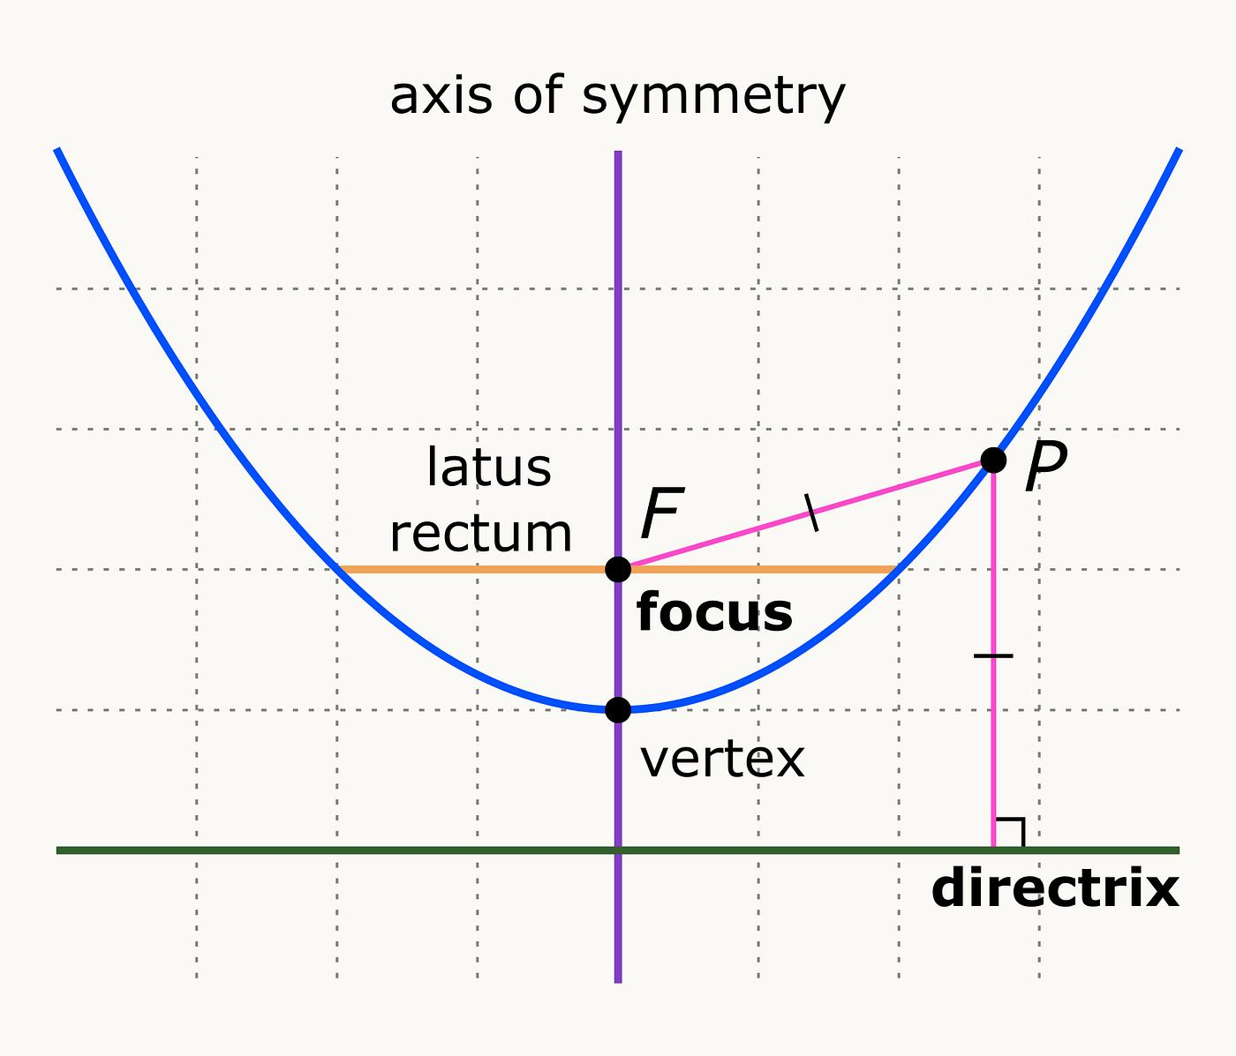
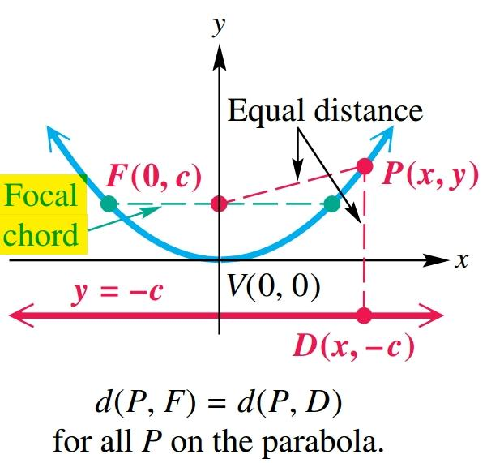
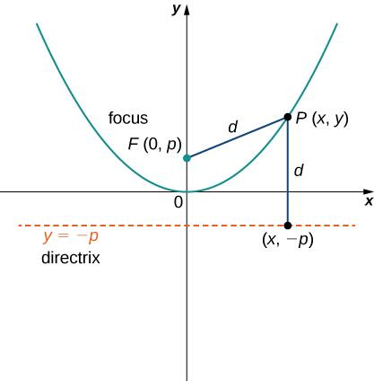
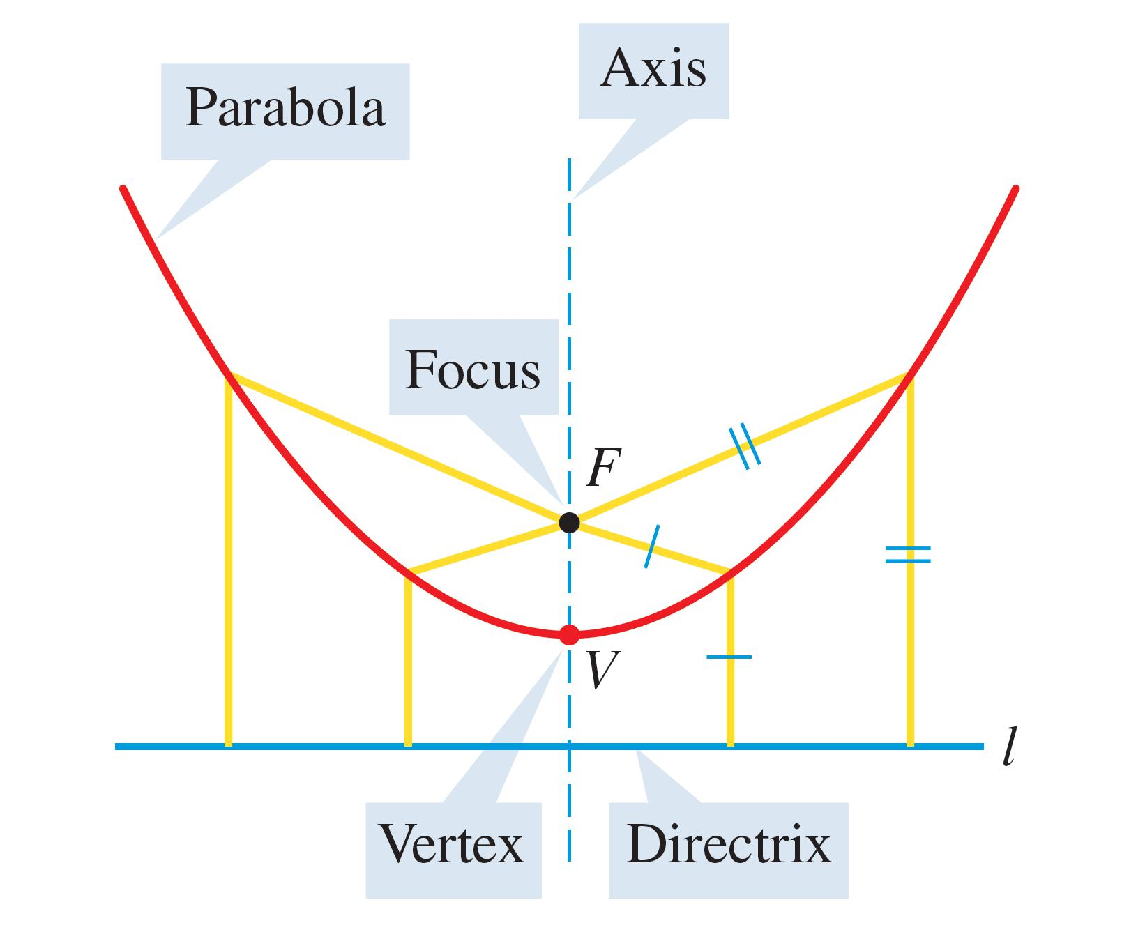
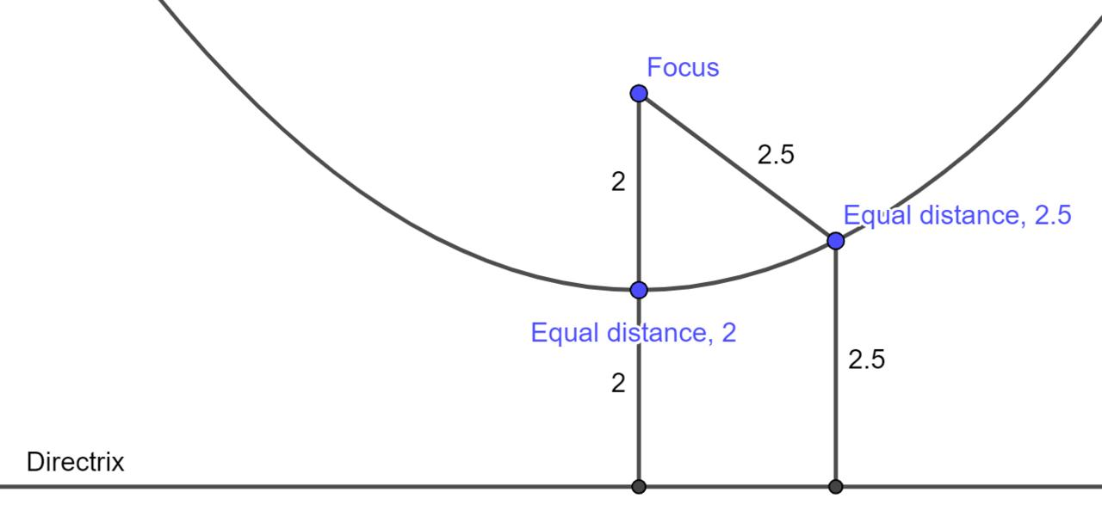

Simple Definition
# Source: AI Source: Provided by: [Data Path: Persons Table -> ID Column: 1, Name_En Column: Motasem Essam] -> From: [ChatGPT] on [7/25/2026]
A parabola is the set of all points that are equally distant from a fixed point and a fixed line.
In other words:
$$\boxed{\text{Distance to focus}=\text{Distance to directrix}}$$
This is the fundamental locus definition of a parabola.

Fundamental Concept
# Source: AI Source: Provided by: [Data Path: Persons Table -> ID Column: 1, Name_En Column: Motasem Essam] -> From: [ChatGPT] on [7/25/2026]
Consider a fixed point $F$and a fixed line $l$.
A variable point $P$belongs to the parabola exactly when:
$$\boxed{PF=d\left(P , l\right)}$$
Therefore:
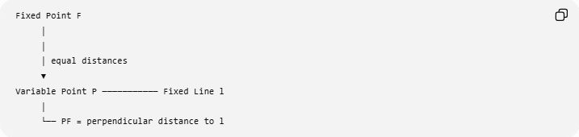
Fixed Point F
│
│
│ equal distances
▼
Variable Point P ─────────── Fixed Line l
│
└── PF = perpendicular distance to l
Every point satisfying this condition belongs to the parabola.
Every point on the parabola satisfies this condition.
Therefore:
$$\boxed{P\text{ lies on the parabola }⟺ PF=d\left(P , l\right)}$$

Main Elements of the Parabola
# Source: AI Source: Provided by: [Data Path: Persons Table -> ID Column: 1, Name_En Column: Motasem Essam] -> From: [ChatGPT] on [7/25/2026]
A parabola as a locus is determined by two fixed geometric objects:
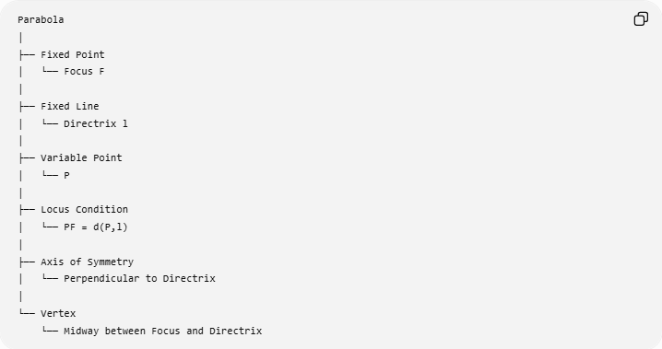
Parabola
│
├── Fixed Point
│ └── Focus F
│
├── Fixed Line
│ └── Directrix l
│
├── Variable Point
│ └── P
│
├── Locus Condition
│ └── PF = d(P,l)
│
├── Axis of Symmetry
│ └── Perpendicular to Directrix
│
└── Vertex
└── Midway between Focus and Directrix

Focus
# Source: AI Source: Provided by: [Data Path: Persons Table -> ID Column: 1, Name_En Column: Motasem Essam] -> From: [ChatGPT] on [7/25/2026]
The focus is the fixed point used in the definition of the parabola.
It is usually denoted by
$$\boxed{F}.$$
Every point $P$on the parabola has a distance $PF$from the focus.
The focus is located on the parabola's axis of symmetry.

Directrix
# Source: AI Source: Provided by: [Data Path: Persons Table -> ID Column: 1, Name_En Column: Motasem Essam] -> From: [ChatGPT] on [7/25/2026]
The directrix is the fixed line used in the definition of the parabola.
It is usually denoted by
$$\boxed{l}.$$
For a point $P$, the distance to the directrix means the perpendicular distance from $P$to the line.
If $Q$is the perpendicular foot from $P$to the directrix, then:
$$PQ⊥l$$
and:
$$\boxed{d\left(P , l\right)=PQ}.$$
Therefore, the parabola condition can also be written:
$$\boxed{PF=PQ}.$$

Locus Construction of a Parabola
# Source: AI Source: Provided by: [Data Path: Persons Table -> ID Column: 1, Name_En Column: Motasem Essam] -> From: [ChatGPT] on [7/25/2026]
A parabola can be generated from the focus-directrix definition.
Suppose $F$and $l$are fixed.
For any chosen distance $d$:
- Choose a point $Q$on the directrix.
- Construct a line through $Q$perpendicular to the directrix.
- Find points $P$satisfying
$$PF=PQ.$$
- Repeat for different positions of $Q$.
- The resulting points form the parabola.
Conceptually:
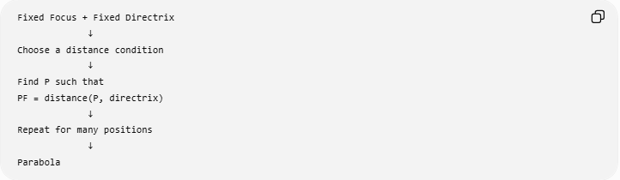
Fixed Focus + Fixed Directrix
↓
Choose a distance condition
↓
Find P such that
PF = distance(P, directrix)
↓
Repeat for many positions
↓
Parabola
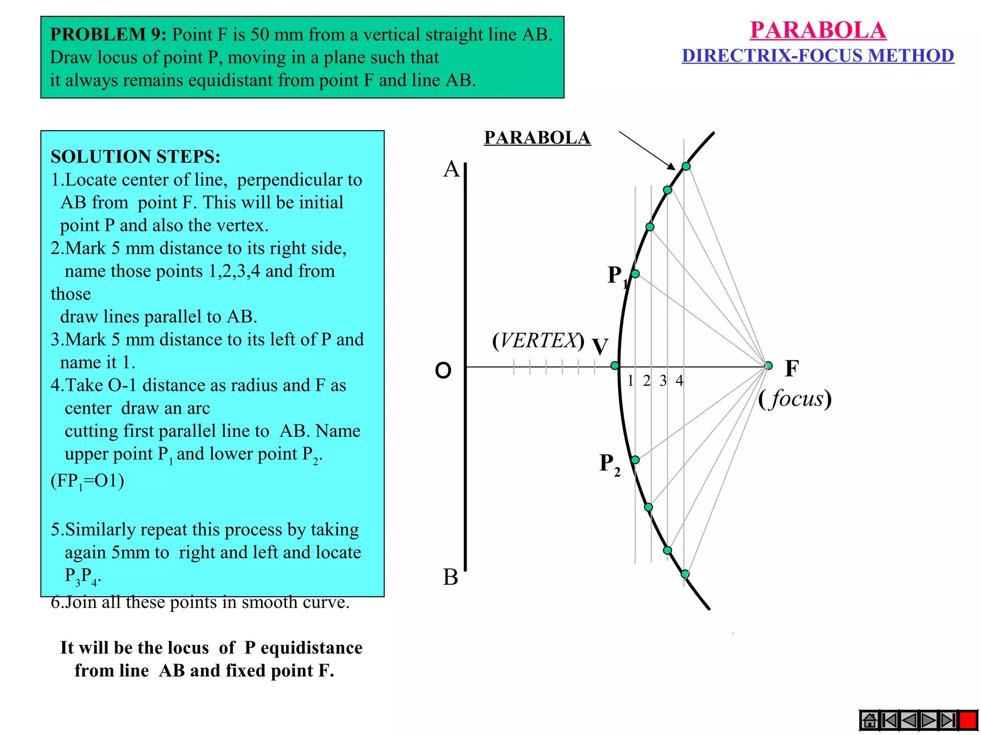
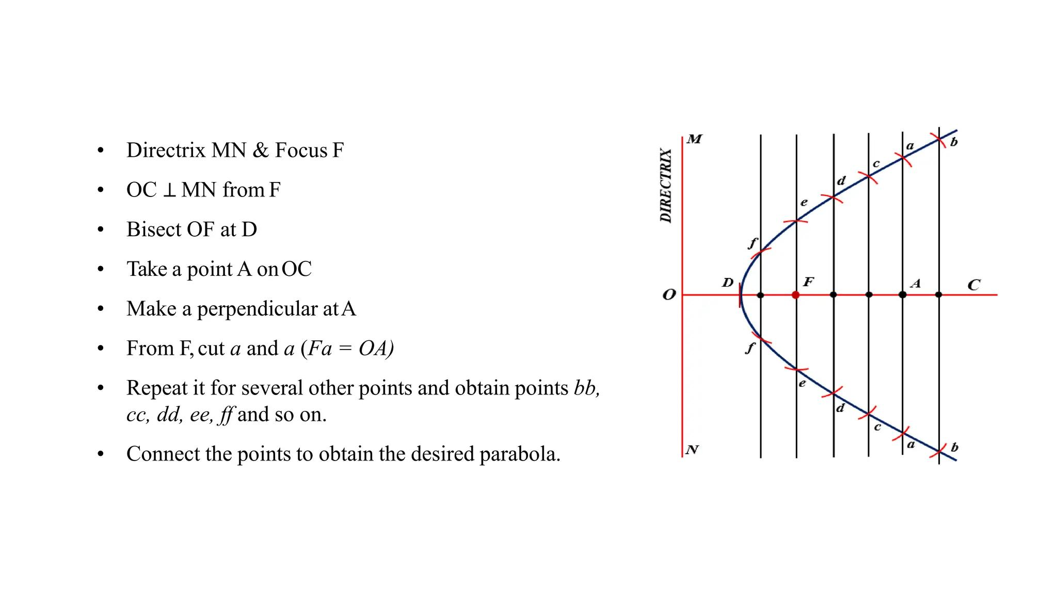
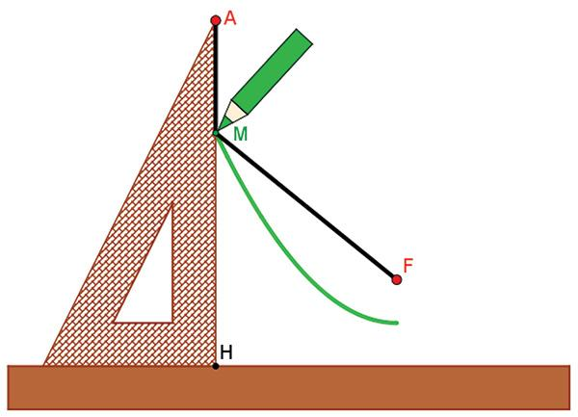
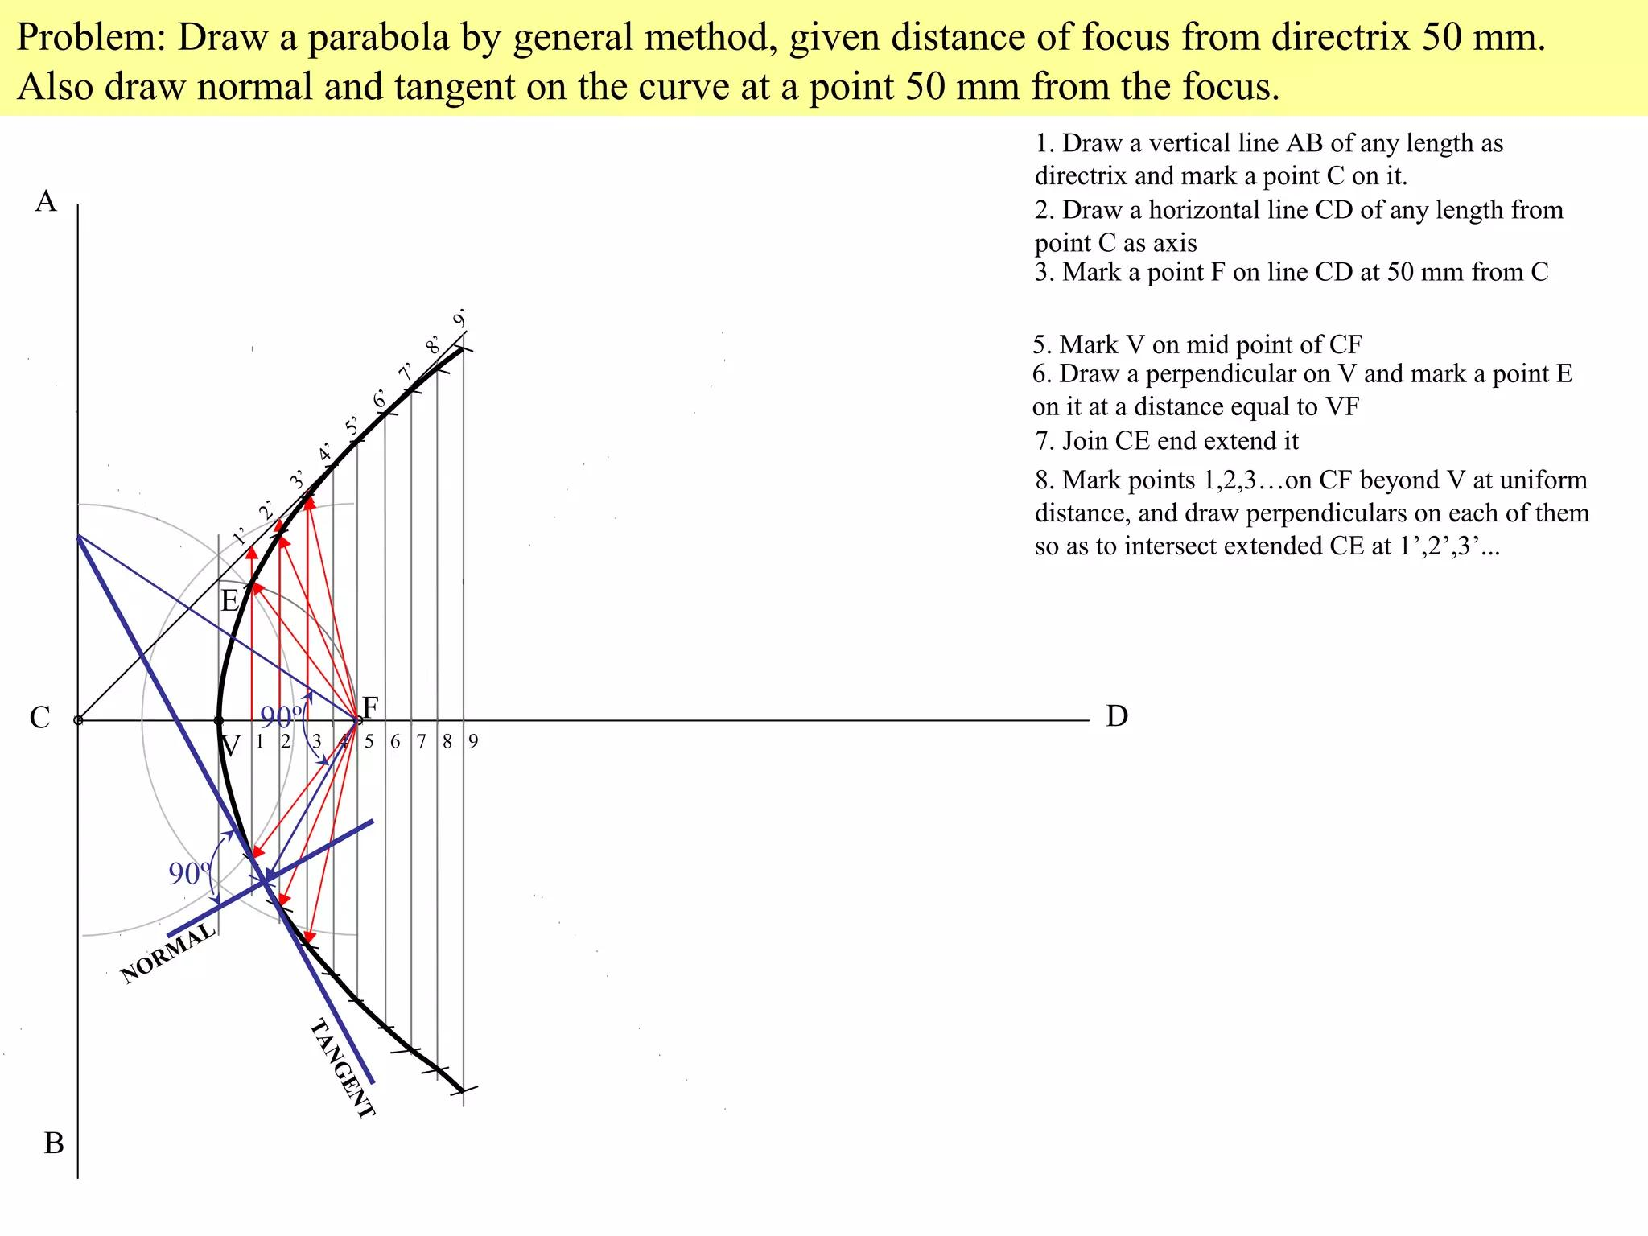
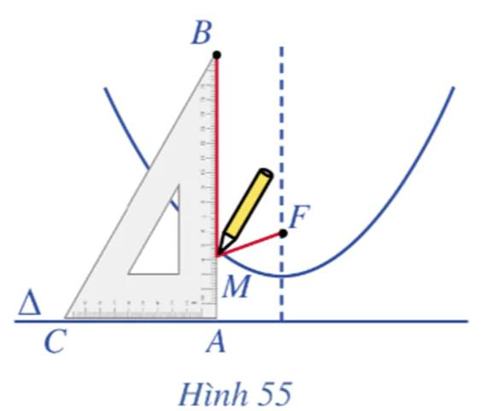

Example 1 — Basic Locus Condition
# Source: AI Source: Provided by: [Data Path: Persons Table -> ID Column: 1, Name_En Column: Motasem Essam] -> From: [ChatGPT] on [7/25/2026]
Suppose the focus is
$$F=\left(0 , 2\right)$$
and the directrix is
$$y=-2.$$
Take a point
$$P=\left(x , y\right).$$
Its distance from the focus is:
$$PF=\sqrt{x^{2}+{\left(y-2\right)}^{2}}.$$
Its perpendicular distance from the directrix $y=-2$is:
$$d\left(P , l\right)=∣y+2∣.$$
Therefore, the locus condition is:
$$\sqrt{x^{2}+{\left(y-2\right)}^{2}}=∣y+2∣.$$
Squaring:
$$x^{2}+{\left(y-2\right)}^{2}={\left(y+2\right)}^{2}.$$
Expanding:
$$x^{2}+y^{2}-4y+4=y^{2}+4y+4.$$
Therefore:
$$x^{2}=8y.$$
So the parabola is:
$$\boxed{x^{2}=8y}.$$

Standard Equation of a Parabola
# Source: AI Source: Provided by: [Data Path: Persons Table -> ID Column: 1, Name_En Column: Motasem Essam] -> From: [ChatGPT] on [7/25/2026]
A standard upward-opening parabola can be written as:
$$\boxed{x^{2}=4py}$$
where $p$is the directed distance from the vertex to the focus.
For this parabola:
$$\boxed{F=\left(0 , p\right)}$$
and the directrix is:
$$\boxed{y=-p}.$$
Therefore:
$$PF=d\left(P , l\right).$$

Example 2 — $x^{2}=12y$
# Source: AI Source: Provided by: [Data Path: Persons Table -> ID Column: 1, Name_En Column: Motasem Essam] -> From: [ChatGPT] on [7/25/2026]
Consider:
$$\boxed{x^{2}=12y}.$$
Compare with:
$$x^{2}=4py.$$
Thus:
$$4p=12$$
so:
$$p=3.$$
Therefore:
- Vertex:
$$\boxed{\left(0 , 0\right)}$$
- Focus:
$$\boxed{\left(0 , 3\right)}$$
- Directrix:
$$\boxed{y=-3}$$
- Axis of symmetry:
$$\boxed{x=0}$$
For every point $P$on the parabola:
$$\boxed{PF=d\left(P , y=-3\right)}.$$

Coordinate Derivation of the Parabola
# Source: AI Source: Provided by: [Data Path: Persons Table -> ID Column: 1, Name_En Column: Motasem Essam] -> From: [ChatGPT] on [7/25/2026]
Take the focus:
$$F=\left(0 , p\right)$$
and directrix:
$$y=-p.$$
Let:
$$P=\left(x , y\right).$$
Distance from $P$to the focus:
$$PF=\sqrt{x^{2}+{\left(y-p\right)}^{2}}.$$
Distance from $P$to the directrix:
$$d\left(P , l\right)=y+p$$
for points in the appropriate region.
The locus condition is:
$$\sqrt{x^{2}+{\left(y-p\right)}^{2}}=y+p.$$
Squaring:
$$x^{2}+{\left(y-p\right)}^{2}={\left(y+p\right)}^{2}.$$
Expand:
$$x^{2}+y^{2}-2py+p^{2}=y^{2}+2py+p^{2}.$$
Therefore:
$$x^{2}=4py.$$
Hence:
$$\boxed{x^{2}=4py}.$$
This equation comes directly from the locus definition.

Vertex as Part of the Locus
# Source: AI Source: Provided by: [Data Path: Persons Table -> ID Column: 1, Name_En Column: Motasem Essam] -> From: [ChatGPT] on [7/25/2026]
The vertex is the point on the parabola closest to both the focus and the directrix.
For:
$$x^{2}=4py,$$
the vertex is:
$$\boxed{V=\left(0 , 0\right)}.$$
The distances from the vertex are:
$$VF=p$$
and:
$$d\left(V , l\right)=p.$$
Therefore:
$$\boxed{VF=d\left(V , l\right)}.$$
So the vertex itself satisfies the locus condition.

Axis of Symmetry
# Source: AI Source: Provided by: [Data Path: Persons Table -> ID Column: 1, Name_En Column: Motasem Essam] -> From: [ChatGPT] on [7/25/2026]
The axis of symmetry passes through:
- the vertex
- the focus
- the midpoint between the focus and the directrix
and is perpendicular to the directrix.
For:
$$x^{2}=4py,$$
the axis is:
$$\boxed{x=0}.$$
The parabola is symmetric about this line.

Different Orientations
# Source: AI Source: Provided by: [Data Path: Persons Table -> ID Column: 1, Name_En Column: Motasem Essam] -> From: [ChatGPT] on [7/25/2026]
A parabola can open in different directions.
Opens upward
$$\boxed{x^{2}=4py}$$
with $p>0$.
Opens downward
$$\boxed{x^{2}=-4py}$$
Opens right
$$\boxed{y^{2}=4px}$$
Opens left
$$\boxed{y^{2}=-4px}$$
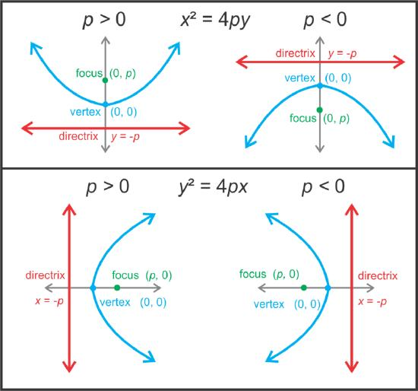
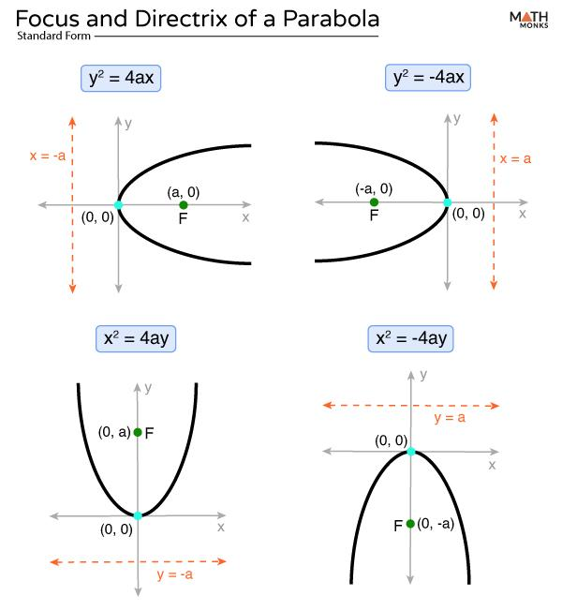
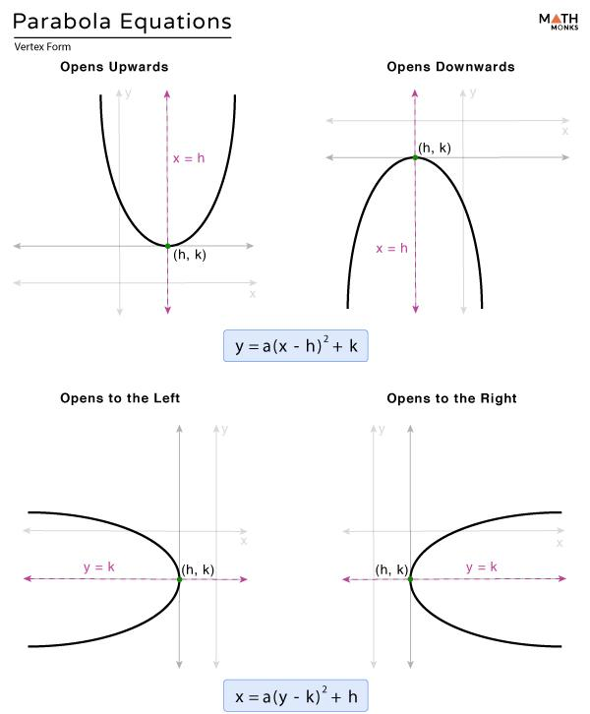
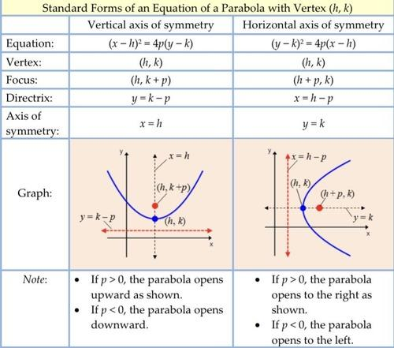

General Vertex Form
# Source: AI Source: Provided by: [Data Path: Persons Table -> ID Column: 1, Name_En Column: Motasem Essam] -> From: [ChatGPT] on [7/25/2026]
If the vertex is:
$$V=\left(h , k\right),$$
then the four standard orientations are:
Upward
$$\boxed{{\left(x-h\right)}^{2}=4p\left(y-k\right)}$$
Downward
$$\boxed{{\left(x-h\right)}^{2}=-4p\left(y-k\right)}$$
Rightward
$$\boxed{{\left(y-k\right)}^{2}=4p\left(x-h\right)}$$
Leftward
$$\boxed{{\left(y-k\right)}^{2}=-4p\left(x-h\right)}$$
Here $p$represents the distance between the vertex and the focus.

Example 3 — Translated Parabola
# Source: AI Source: Provided by: [Data Path: Persons Table -> ID Column: 1, Name_En Column: Motasem Essam] -> From: [ChatGPT] on [7/25/2026]
Consider:
$$\boxed{{\left(x-2\right)}^{2}=8\left(y-1\right)}.$$
Compare with:
$${\left(x-h\right)}^{2}=4p\left(y-k\right).$$
Therefore:
$$h=2, k=1, 4p=8.$$
Thus:
$$p=2.$$
So:
- Vertex:
$$\boxed{\left(2 , 1\right)}$$
- Focus:
$$\boxed{\left(2 , 3\right)}$$
- Directrix:
$$\boxed{y=-1}$$
- Axis:
$$\boxed{x=2}$$
Every point $P$on this parabola satisfies:
$$\boxed{PF=d\left(P , y=-1\right)}.$$

Parabola Compared with Other Locus Curves
# Source: AI Source: Provided by: [Data Path: Persons Table -> ID Column: 1, Name_En Column: Motasem Essam] -> From: [ChatGPT] on [7/25/2026]
The parabola belongs to a major family of loci defined by distance conditions.
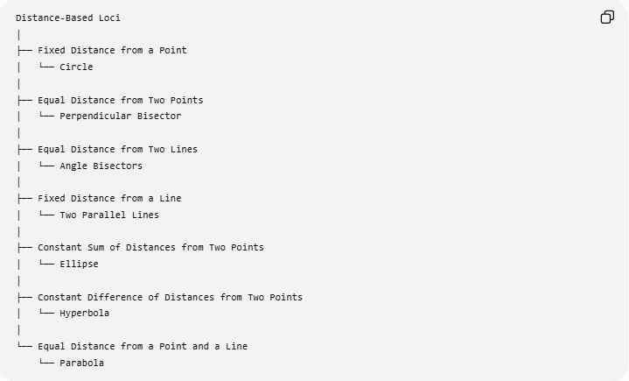
Distance-Based Loci
│
├── Fixed Distance from a Point
│ └── Circle
│
├── Equal Distance from Two Points
│ └── Perpendicular Bisector
│
├── Equal Distance from Two Lines
│ └── Angle Bisectors
│
├── Fixed Distance from a Line
│ └── Two Parallel Lines
│
├── Constant Sum of Distances from Two Points
│ └── Ellipse
│
├── Constant Difference of Distances from Two Points
│ └── Hyperbola
│
└── Equal Distance from a Point and a Line
└── Parabola
This gives an important classification:
$$\boxed{\text{Parabola}=\text{Point-Line Equidistance Locus}}$$

Parabola vs Circle
# Source: AI Source: Provided by: [Data Path: Persons Table -> ID Column: 1, Name_En Column: Motasem Essam] -> From: [ChatGPT] on [7/25/2026]
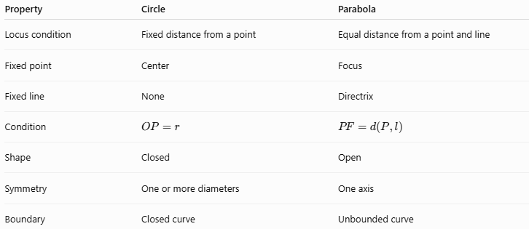
Property | Circle | Parabola
Locus condition | Fixed distance from a point | Equal distance from a point and line
Fixed point | Center | Focus
Fixed line | None | Directrix
Condition | $$OP=r$$ | $$PF=d\left(P , l\right)$$
Shape | Closed | Open
Symmetry | One or more diameters | One axis
Boundary | Closed curve | Unbounded curve
The key difference is:
$$\boxed{\text{Circle: point-to-point distance}}$$
while:
$$\boxed{\text{Parabola: point-to-point vs point-to-line distance}}$$

Parabola vs Ellipse
# Source: AI Source: Provided by: [Data Path: Persons Table -> ID Column: 1, Name_En Column: Motasem Essam] -> From: [ChatGPT] on [7/25/2026]
An ellipse is defined using two fixed points:
$$\boxed{PF_{1}+PF_{2}=\text{constant}}.$$
A parabola uses:
$$\boxed{PF=d\left(P , l\right)}.$$
Therefore:
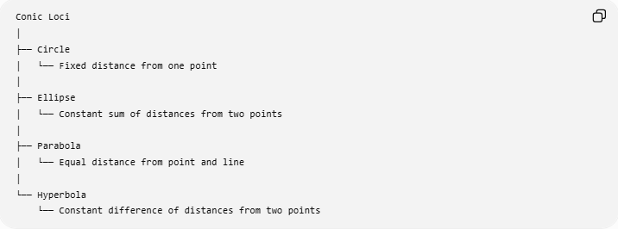
Conic Loci
│
├── Circle
│ └── Fixed distance from one point
│
├── Ellipse
│ └── Constant sum of distances from two points
│
├── Parabola
│ └── Equal distance from point and line
│
└── Hyperbola
└── Constant difference of distances from two points

Parabola vs Hyperbola
# Source: AI Source: Provided by: [Data Path: Persons Table -> ID Column: 1, Name_En Column: Motasem Essam] -> From: [ChatGPT] on [7/25/2026]
A hyperbola is defined by:
$$\boxed{∣PF_{1}-PF_{2}∣=\text{constant}}.$$
A parabola is defined by:
$$\boxed{PF=d\left(P , l\right)}.$$
Thus:
$$\boxed{\begin{aligned}\text{Parabola}&→\text{point-line distance equality} \\ \text{Hyperbola}&→\text{two-point distance difference}\end{aligned}}$$

Important Property of the Locus
# Source: AI Source: Provided by: [Data Path: Persons Table -> ID Column: 1, Name_En Column: Motasem Essam] -> From: [ChatGPT] on [7/25/2026]
The defining condition works in both directions:
If $P$lies on the parabola:
$$\boxed{PF=d\left(P , l\right)}.$$
If a point satisfies:
$$\boxed{PF=d\left(P , l\right)},$$
then it lies on the parabola.
Therefore:
$$\boxed{P∈\text{Parabola }⟺ PF=d\left(P , l\right)}$$
This is what makes the focus-directrix definition a true locus definition.

Classification Summary
# Source: AI Source: Provided by: [Data Path: Persons Table -> ID Column: 1, Name_En Column: Motasem Essam] -> From: [ChatGPT] on [7/25/2026]
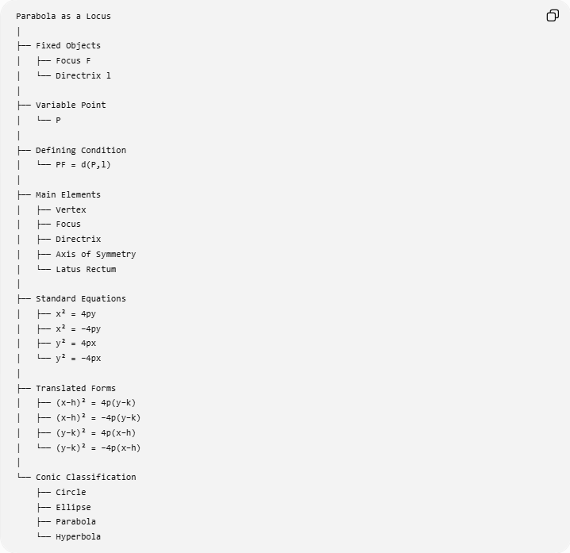
Parabola as a Locus
│
├── Fixed Objects
│ ├── Focus F
│ └── Directrix l
│
├── Variable Point
│ └── P
│
├── Defining Condition
│ └── PF = d(P,l)
│
├── Main Elements
│ ├── Vertex
│ ├── Focus
│ ├── Directrix
│ ├── Axis of Symmetry
│ └── Latus Rectum
│
├── Standard Equations
│ ├── x² = 4py
│ ├── x² = −4py
│ ├── y² = 4px
│ └── y² = −4px
│
├── Translated Forms
│ ├── (x−h)² = 4p(y−k)
│ ├── (x−h)² = −4p(y−k)
│ ├── (y−k)² = 4p(x−h)
│ └── (y−k)² = −4p(x−h)
│
└── Conic Classification
├── Circle
├── Ellipse
├── Parabola
└── Hyperbola

Key Points
# Source: AI Source: Provided by: [Data Path: Persons Table -> ID Column: 1, Name_En Column: Motasem Essam] -> From: [ChatGPT] on [7/25/2026]
- A parabola is a locus.
- It is defined using a fixed point and a fixed line.
- The fixed point is the focus.
- The fixed line is the directrix.
- Every point $P$on the parabola satisfies:
$$\boxed{PF=d\left(P , l\right)}$$
- The distance to the directrix is always measured perpendicularly.
- The vertex lies halfway between the focus and directrix along the axis.
- The axis of symmetry is perpendicular to the directrix.
- The standard equation
$$x^{2}=4py$$
follows directly from the focus-directrix locus definition.
- A parabola is an open conic.
- Unlike a circle, it is not bounded.
- Unlike an ellipse and hyperbola, its fundamental distance definition involves one fixed point and one fixed line.

Conclusion
# Source: AI Source: Provided by: [Data Path: Persons Table -> ID Column: 1, Name_En Column: Motasem Essam] -> From: [ChatGPT] on [7/25/2026]
The parabola as a locus is one of the fundamental examples of a distance-defined locus. Given a fixed point $F$and a fixed line $l$, the set of all points $P$satisfying
$$\boxed{PF=d\left(P , l\right)}$$
forms a parabola.
Therefore, the essential principle is:
$$\boxed{\text{Equal distance from a fixed point and a fixed line}⟶\text{Parabola}}$$
This places the parabola naturally within the broader classification of conic loci.

